**National University of Computer & Emerging Sciences Karachi Campus.**



**Project Proposal:**

**COURSE: DATABASE**

**Section: 5A**

**­­PROJECT TEAM:**

1. Salman Mehmood 19K-1317
2. Muhammad Rasan 19K-0300
3. Syed Muhammad Danish 19K-1299

**Topic:**

**Event Management System**

**Goal:**

To create a web application of Event Management system.

**Description:**

Our project is an event management system. We thought to work on this project when we found out that there is not a proper system to be used in concert events. The first main problem that we want to cater with this system is data loss. Second is accounts. Other things include guest data, artist data, sponsors data, recent events data and logistics. We want to combine all the key entities of an event into one single database from where we can operate and control future events.

**List of Features:**

* Billing
* Retaining history
* Payments record
* Analysis (of previous events)

**ER DIAGRAM:**

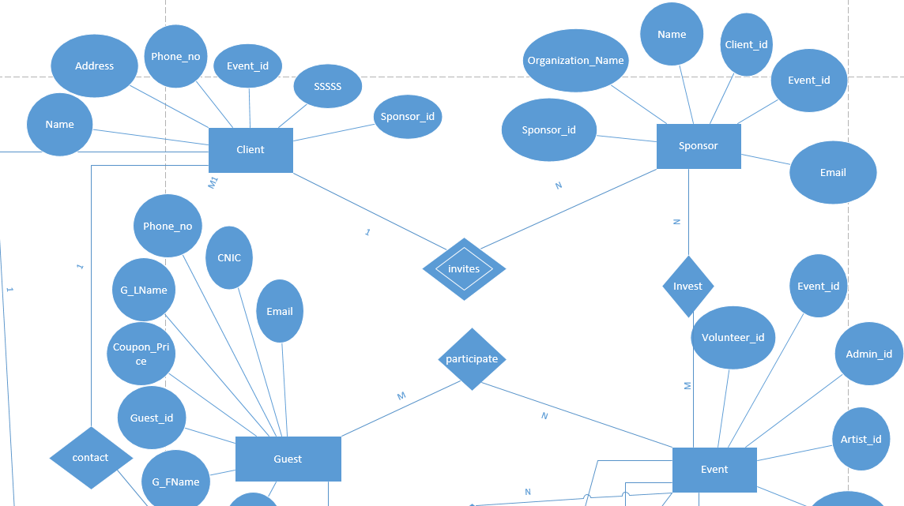

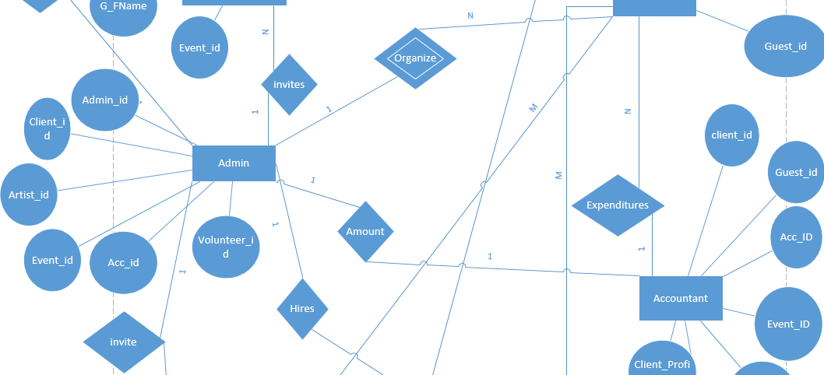

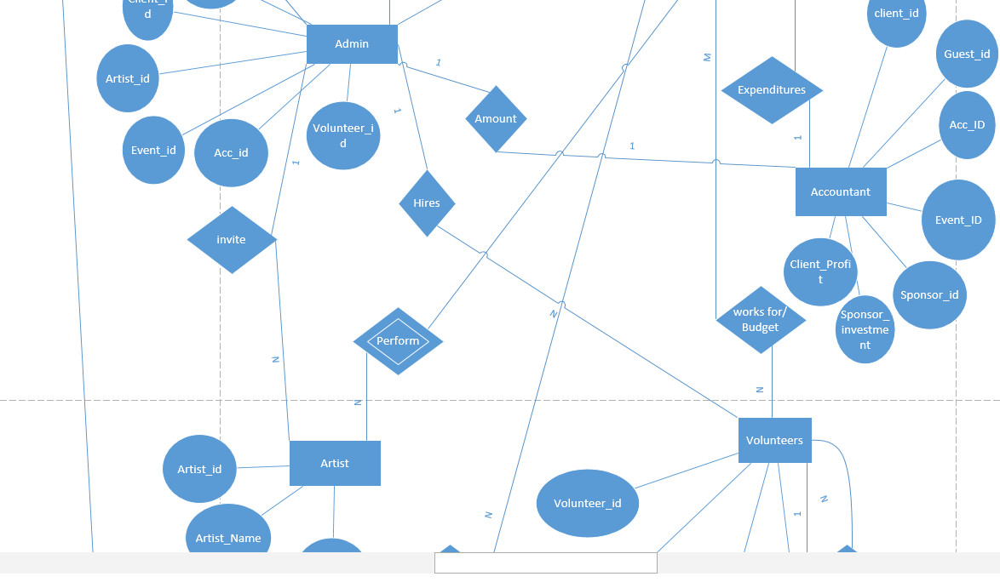

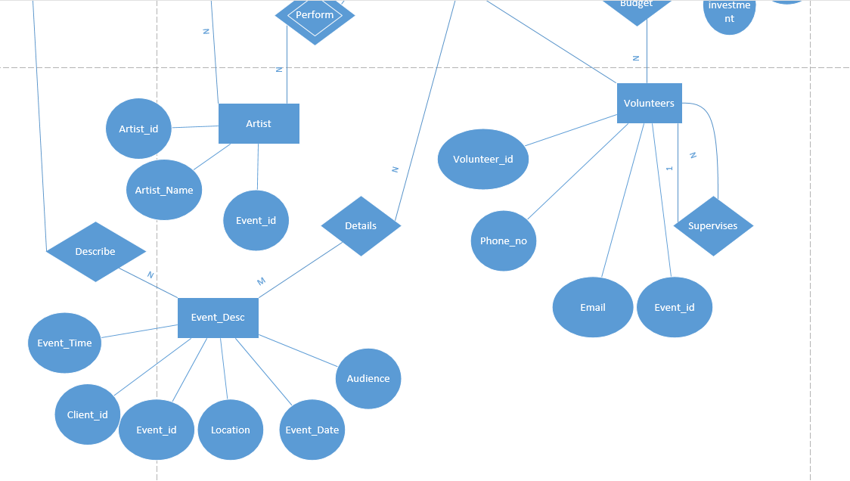

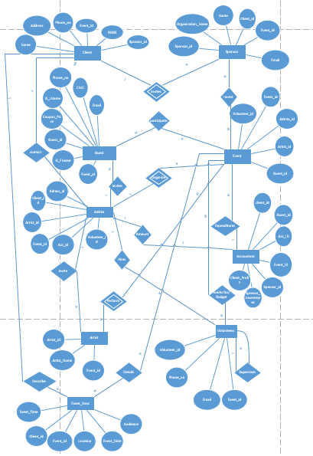

**Tools & Techniques:**

* HTML
* CSS
* PHP
* MS.SQL
* related libraries and tools

**Course Instructor:**

Sir M.Danish Khan

**Signatur****:**